FOR IMMEDIATE RELEASE 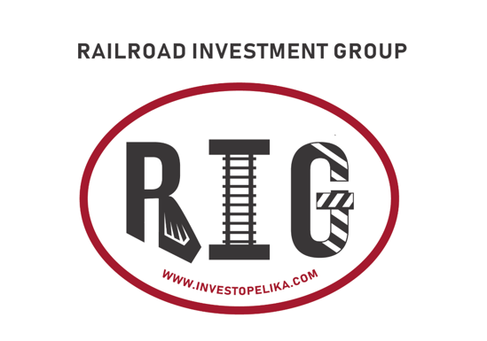

Contact:
Blake Henry
334-748-9999
blake@rigopelika.com

BLAKE HENRY RECOGNIZED AS ONE OF LPL FINANCIAL’S TOP FINANCIAL ADVISORS

Opelika, Alabama —December 6, 2021– Blake Henry, an independent LPL Financial advisor at Railroad Investment Group in Opelika, today announced his inclusion in LPL’s Director’s Club. With more than 17,000 LPL-affiliated advisors nationwide, LPL awards select advisors with this distinction based on an advisor’s business success*.
“On behalf of LPL, I congratulate Blake Henry on reaching this milestone in their professional career,” said Angela Xavier, LPL executive vice president, Independent Advisor Services. “Business owners, American investors and industries at large faced extraordinary challenges throughout 2021. In the advisor-mediated financial advice market, investors showed how much value they place on a trusting relationship with a financial advisor. We applaud Blake for his commitment to clients and resiliency as a business owner, and we are inspired by his dedication to making a meaningful impact in the lives of his clients. It is an honor to support Blake and wish his entire team continued success as they continue to add value for clients and in their business in the years ahead.”

Blake Henry is affiliated with LPL Financial, the nation’s largest independent broker-dealer** and a leader in the retail financial advice market. LPL provides the resources, tools and technology that support advisors in their work to enrich their clients’ financial lives.

About LPL Financial
LPL Financial is a leader in the retail financial advice market and the nation’s largest independent broker/dealer**. We serve independent financial advisors and financial institutions, providing them with the technology, research, clearing and compliance services, and practice management programs they need to create and grow thriving practices. LPL enables them to provide objective guidance to millions of American families seeking wealth management, retirement planning, financial planning and asset management solutions. LPL.com
*Achievement is based on top 30% of annual production among LPL Advisors only.
**Based on total revenues, Financial Planning magazine June 1996 – 2020

Securities offered through LPL Financial, Member FINRA/SIPC. Investment advice offered through Railroad Investment Group, a registered investment advisor.
LPL Financial representatives associated with this site may only discuss an/or transact securities business with residents of the following states: AL, CA, CO, FL, GA, ID, IL, IN, MS, NM, NC, OH, OR, TN, TX, VA.
All information herein has been prepared solely for informational purposes, and it is not an offer to buy or sell, or a solicitation of an offer to buy or sell any security or instrument or to participate in any particular trading strategy. LPL Privacy Policy LPL is not responsible for and may not be held liable for the adequacy of the information available on the link(s) provided. The listing of a vendor or product on this/these site(s) does not constitute an endorsement or warranty of the vendor or product by LPL

